**Installing and running the application**

Introduction

This installation procedure describes how to download, install and run the application, either locally (on your personal computer, so only accessible to you or your local network) or on a public cloud server such as <https://www.shinyapps.io/>. The advantage of the cloud server is that anyone can log in on the application (note that you can configure a password if desired to control access to your application). Both options are described below for a Windows computer.

Option 1: Local Installation

1.1 Install R base

To run our application, it is sufficient to install the “R base” version.

Download and install the latest version of R from <https://cran.rstudio.com/> . If you are not experienced in R, select the latest R base version for Windows, which can be downloaded as an installation exe file. On downloading the exe file, simply double click the exe and follow the installation prompts.

Verify that R is installed properly by starting R from command line:

- in the windows search bar, type ‘*cmd*’, then select the command prompt

- go to the directory where R is installed (by default this is C:\Program Files\R, followed by a version-specific directory, eg. C:\Program Files\R\R-4.1.3), then enter the bin directory. In our example, we would need to type “*cd C:\Program Files\R\R-4.1.3\bin*” in the command prompt, followed by Enter

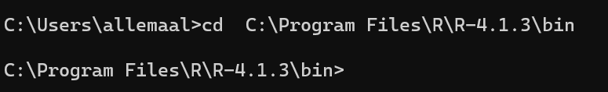

- Once in C:\Program Files\R\R-4.1.3,\bin type “*R.exe*”, followed by Enter to start R in command line. If R was installed successfully, you will see the following output: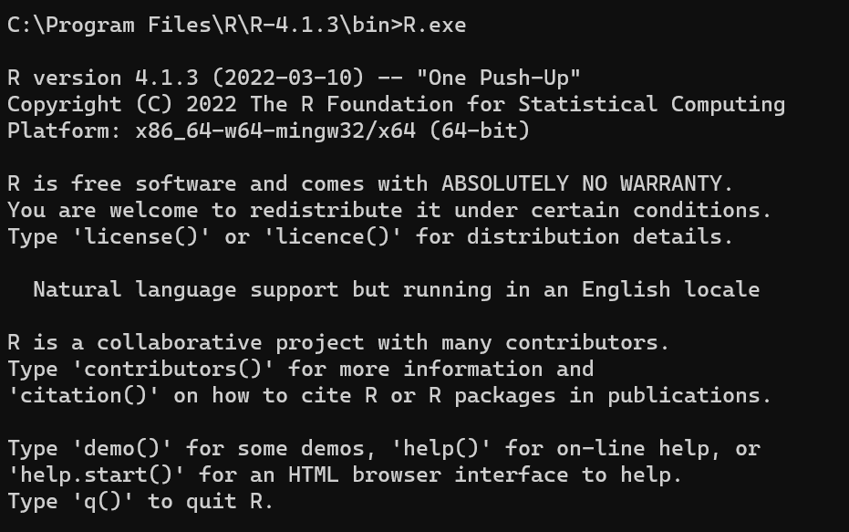   
 

1.2 Install RStudio Desktop

Download and install the latest version of “RStudio Desktop” from

[https://support](https://support/)[—rstudio-com.netlify.app/products/rstudio/download/#download](https://support--rstudio-com.netlify.app/products/rstudio/download/#download). For our purposes, the free version is sufficient, which is available as an exe installation file. On downloading the exe file, double click the exe and follow the installation prompts.

To verify that RStudio was installed successfully, type “*RStudio”* in the windows search bar. The RStudio app should appear and selecting it should trigger the startup of RStudio (see screenshot below).

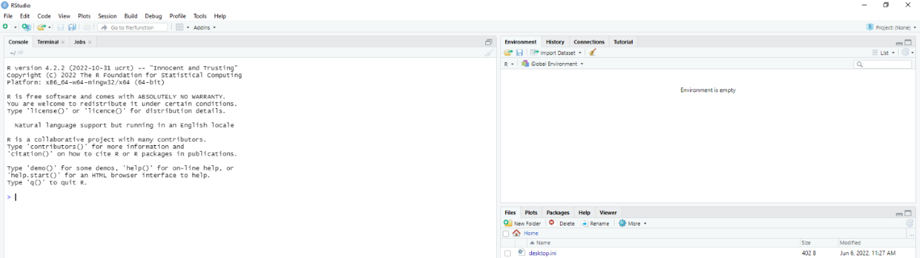

*Notes:*

1. *If a pop-up appears that a newer version of R is available, please follow the prompts to download and install the latest version*
2. *please make sure that your java version is the same as your R version (ie x32 or x64) - see* [*How to load the {rJava} package after the error “JAVA_HOME cannot be determined from the Registry” | R-bloggers*](https://www.r-bloggers.com/2012/08/how-to-load-the-rjava-package-after-the-error-java_home-cannot-be-determined-from-the-registry/)

After verifying that R is installed, you can now install the packages that are required to run our application.  To do so, enter the following commands in the R-interface: *install.packages(c('shinydashboard','DT','shinyjs','shinyWidgets','plotly','xlsx','writexl','rmarkdown','webshot','shiny','ggplot2','reshape2','rootSolve','shinyjs','tidyr','dplyr','deSolve','openxlsx'))*

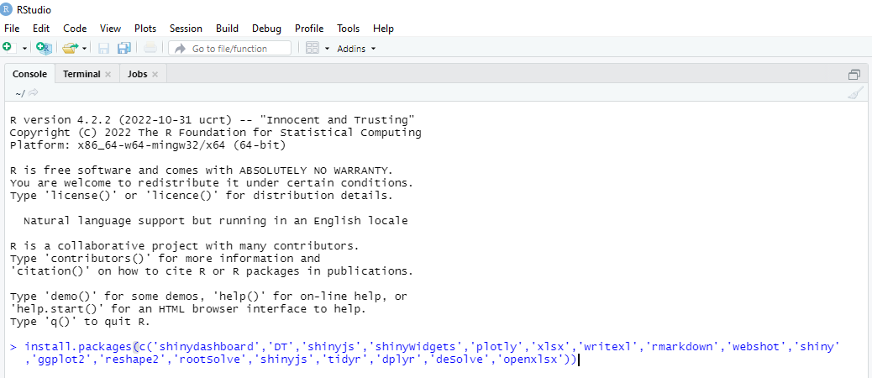

1 .3 Run the Rshiny application

Go to Githublocation, and download the zip file (see screenshot).

Unzip the application zip file, and copy these to a directory of your choice, eg “C:\Rapps\BimSim”. After unzipping, the folder structure should look like the screenshot below: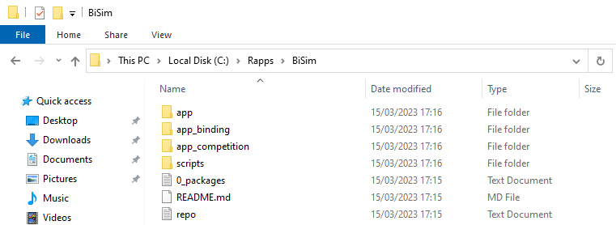Please verify that the ”app” folder contains the ”server.r” and ”ui.r” files, as in the screenshot below:

In RStudio, select “File”, then “New Project”. The pop-up wizzard “New Project” appears, select “Existing Directory – Associate project with an existing directory”. Enter the directory where the “server.r” and “ui.r” files are located (eg “C:\Rapps\BiSim\app”), then select “Create project”.

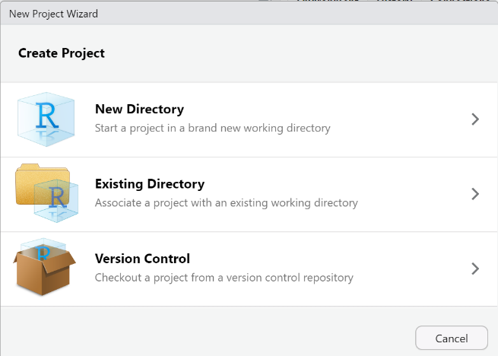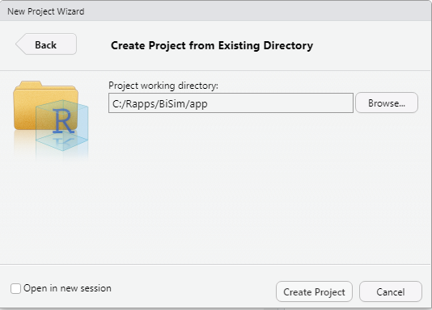   
   
Now the files are loaded as a project. In the console window of RStudio, type “shiny::runApp()”, this will launch the app in a pop-up window:

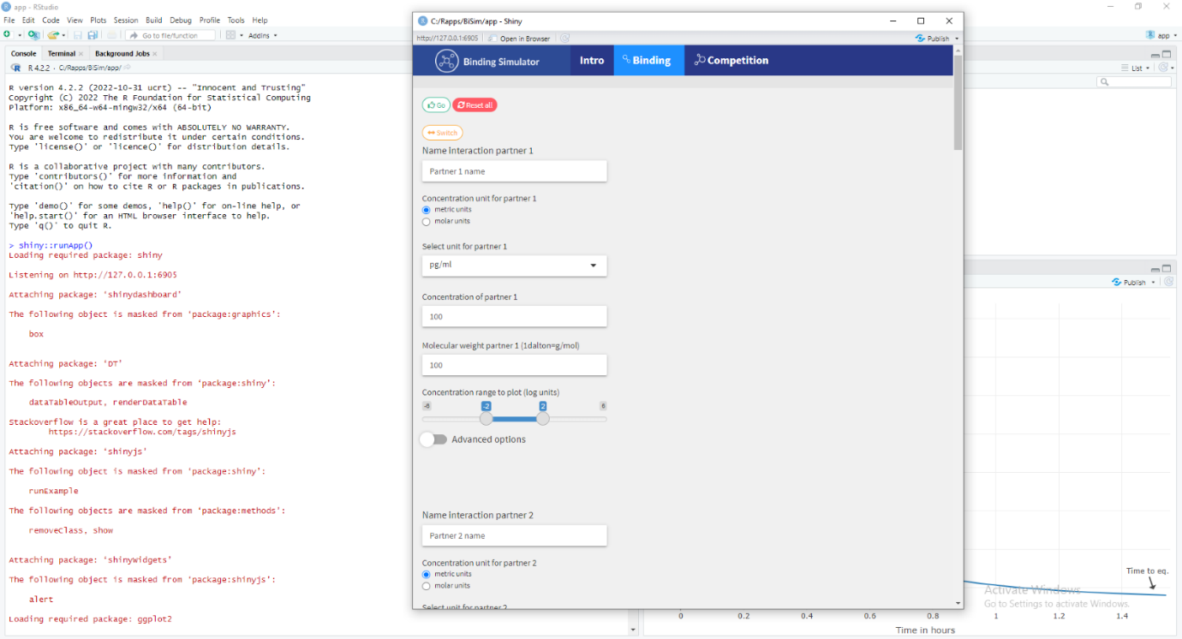Note that all code and is exposed in Rstudio and that the graphs are plotted in Rstudio. For teh best experience, we recommend to click on  the ”Open in Browser” button  at the top of the window running the app:

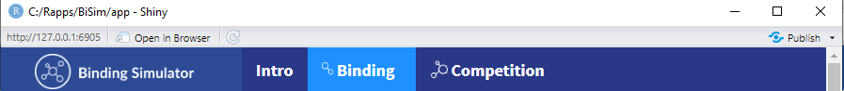

Once running in your web browser, you can scroll down to use the intractive interface & graphs –not you need to update your parameter settinsg by using the “Go” button, see teh extended user manual.

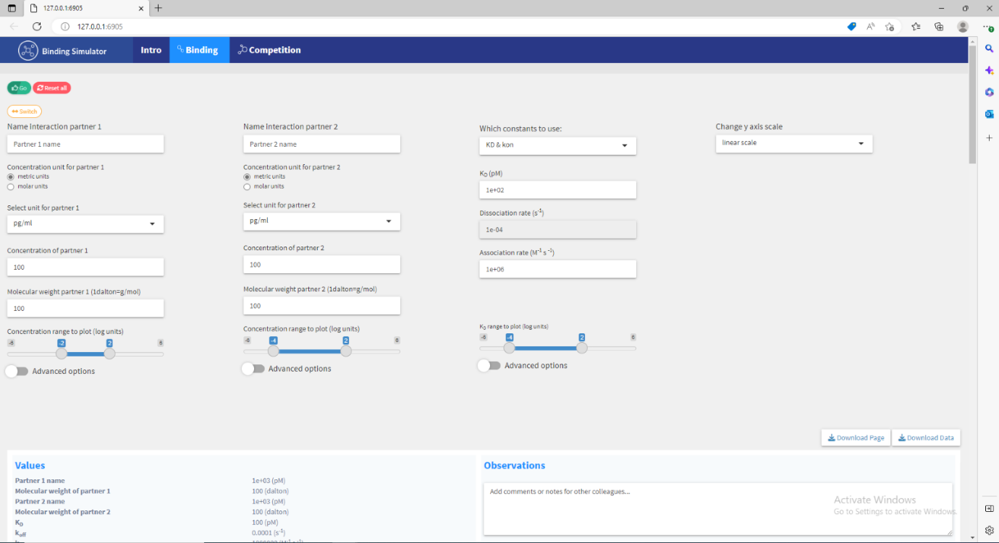

Option 2: cloud hosted

To run the application on a public cloud server, we use RStudio to directly publish to <https://www.shinyapps.io/>.

2.1. install R and RStudio

Follow the steps as described under Option 1, until you have installed all required packages. Then, install one extra package, rsconnect. To do so, type “install.packages(c('rsconnect'))” followed by Enter.

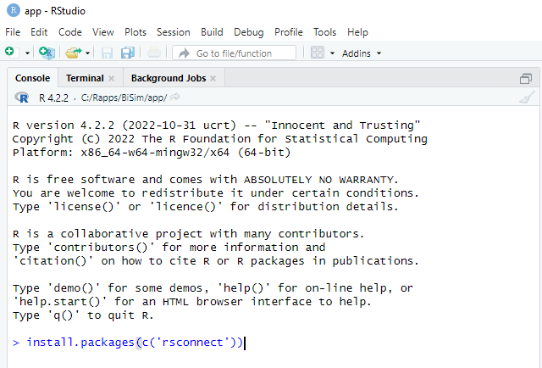

After installing this extra package, proceed with “1 .3 Run the Rshiny application“, until you have the application running locally.

2.2. Publish the application on the cloud

Once the app is running locally in your browser, you can publish it to shinyapps.io by clicking the “publish” button at the top right corner of the Rshiny browser window.

Select “ShinyApps.io”, and connect to your Rshiny account. If you don’t have an Rshiny account yet, follow the detailed instructions on <https://shiny.rstudio.com/articles/shinyapps.html> (sections “Create a shinyapps.io account” and “Configure rsconnect”). The rsconnect package will ensure all the required packages are automatically installed on the cloud server, and that your app is properly deployed.

